**Legal and Social:**

Film industry faces a growing number of sexual harassment report which started when Harvey Weinstein was accused of sexual harassment back in October 2017.1 Harvey Weinstein is a well-known film producer and during the investigation, it was revealed there had been three decades worth of undisclosed sexual accusations which led to his arrest.1 Weinstein arrest created a social movement called Weinstein effect, in which other actors, directors, and politicians are accused of sexual harassment. In The New York Times they have a list of 71 men who were accused for sexual harassment and have resigned from their respected occupation.2

USA TODAY created a survey done to a group of 843 women who work in the entertainment industry asking them if they had been in some way a victim of sexual harassment. The result was that 94% of the women surveyed responded with a yes, in having been a victim of sexual harassment. In the survey, the lists show the types of sexual harassment one experiences, unwelcome sexual comments being the top of the list. 3

Producers Guild of America (PGA) are implementing new guidelines to fight against sexual harassment in movie production sets. These are just guidelines meaning it is just an informational reminder to respect each other. However, producers can leave the PGA when they like to and not be bound by the new guidelines.4

**CITATION**

1. Kantor J, Twohey M. Harvey Weinstein Paid Off Sexual Harassment Accusers for Decades. The New York Times. https://www.nytimes.com/2017/10/05/us/harvey-weinstein-harassment-allegations.html. Published October 5, 2017. Accessed February 1, 2019.
2. Almukhtar S, Gold M, Buchanan L. After Weinstein: 71 Men Accused of Sexual Misconduct and Their Fall From Power. The New York Times. https://www.nytimes.com/interactive/2017/11/10/us/men-accused-sexual-misconduct-weinstein.html. Published November 11, 2017. Accessed February 1, 2019.
3. Puente M, Kelly C. How common is sexual misconduct in Hollywood? USA Today. https://www.usatoday.com/story/life/people/2018/02/20/how-common-sexual-misconduct-hollywood/1083964001/. Published February 23, 2018. Accessed February 1, 2019.
4. Margolis Z. Guidelines are a start, but sexual harassment in the film industry is not going away soon. The Guardian. https://www.theguardian.com/film/2018/jan/26/sexual-harassment-film-industry-producers-guild-of-america. Published January 26, 2018. Accessed February 1, 2019.

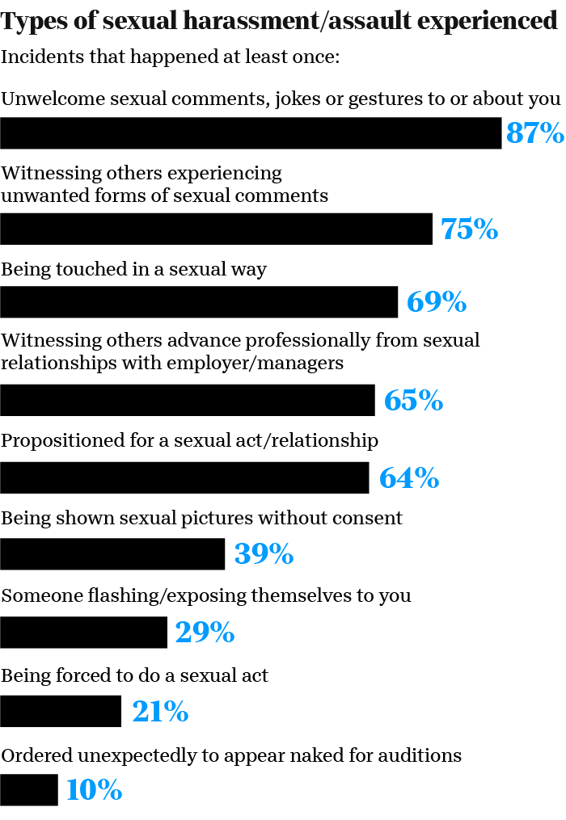3. The 94% types of sexual harassment the victims went through.

**Politics**

Trump's border wall and discrimination towards the Latino can lead to a decreased number of Latino moviegoers.5 According to Theatrical Market Statistics, it shows that the second largest group of moviegoers are Hispanics/Latinos and just recently in 2016 the number has gone up.5 Political pressure that is dehumanizing Hispanics, and the lowering the number of Hispanic lead roles. Could eventually discourage Latinos moviegoers, a reduction that will hurt sales.5,6

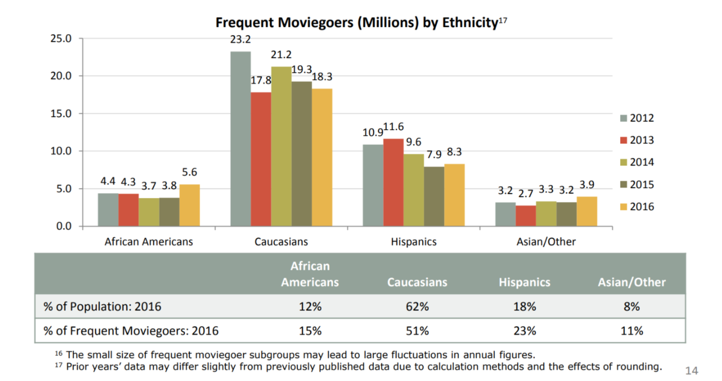

7. Moviegoes according Motion Pictures Cinemea, Theatrical Market Statistics

**CITATION**

1. Sanchez F. What's Hollywood got against Latinos? CNN. https://www.cnn.com/2017/04/03/opinions/latinos-hollywood-sanchez/index.html. Published April 3, 2017. Accessed February 1, 2019.
2. Esai Morales On Latinos, Hollywood and Trump. NBCNews.com. https://www.nbcnews.com/news/latino/esai-morales-latinos-hollywood-trump-n426866. Accessed February 1, 2019.
3. Dodd CJ. Theatrical Market Statistics. 2016.

**Environment and Technology**

Colombia University journal page State of the Planet writes on how the movie industry is working on reducing its environmental impacts. Such as reducing Carbon and Green Gas Offset, Waste Diversion, Transportation, Water Use Reduction and Energy Efficiency. Carbon and Green Gas which is created from traveling to movie sites, transporting supplies, power generators, and pyrotechnical equipment. Film Industry companies like 21st Century Fox has contracted a third-party company to help the company stay on track, help improve the reduction of carbon emissions. As well as, PGA implementing guidelines for the movie production. Waste is caused by actor props, backdrops, movie set props, and leftover food. So, companies like Sony Pictures located in Culver City CA have partnered up with the city to donate, instead of throwing it away as waste. Transportation is one of the largest greenhouse gas contributors so companies like CBS Entertainment are beginning to use hybrid vehicles and completely electric vehicles to reduce carbon emissions. Water is being conserved by industries like NBC Universal that are recycling rainwater and installing water filtration systems to reduce plastic waste. Energy efficiency like Warner Brother Studios which have installed solar roofs that are helping them run their studio. 8

**CITATION**

1. Cut! How the Entertainment Industry is Reducing Environmental Impacts. State of the Planet. https://blogs.ei.columbia.edu/2018/03/29/entertainment-industry-sustainability/. Published March 29, 2018. Accessed February 1, 2019.